Questions Electrochemical Cells Year 12
Examine the following combination of half -cells.
- Cd(s) | Cd²⁺ (aq) half cell combined with Ag+ (aq) | Ag (s)
- Pt(s) | IO₃⁻ (aq), H⁺ (aq) half cell combined with Zn ²⁺ (aq) | Zn (s)
- Pb (s) | Pb²⁺ (aq) half cell combined with Ni ²⁺ (aq) | Ni (s)
- C(s) | ClO₄ - (aq) , H+ (aq) , Cl- (aq) half cell combined with Fe³⁺ (aq) | Fe (s)
- For each of the above create a sketch of the cell similar to the following
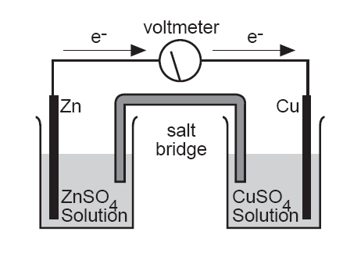
- Label the cell with the following:
- anode/ negative electrode.
- cathode/ positive electrode.
- direction of current flow.
c) Write the following:
- the oxidation half reaction.
- the reduction half reaction .
- overall reaction.
- voltage of the cell.

Part Two Predicting voltages of electrochemical cells
1) For the following electrochemical cells:
a. Write out the oxidation and reduction half reactions using the reduction half reaction tables provided.
b. Write out the overall reaction that occurs in the electrochemical cell.
c. Determine the voltage of the electrochemical cell.
a) Na(s) / Na ⁺ (aq) || Ag ⁺ (aq) / Ag (s)
b) Pt (s) / H+ (aq) || Cu²⁺ (aq) / Cu (s)
c) Sn (s) / Sn ²⁺ (aq) || Au ⁺ (aq) / Au (s)
2) For the following net ionic reactions:
a. Determine what substance is oxidizing and reducing.
b. Determine the oxidation and reduction half reactions that are occurring in the cell. (using a table provided).
c. Predict the voltage that would occur if the electrochemical cell was created.
d. Write out a description of the electrochemical cell like those in question one ( note if no solid is present in the half reaction, then the reaction would have to occur at a inert electrode, either carbon or platinum).
1) | 2I- (aq) | + | Br₂(l) |  | I₂ (s) | + | 2Br- (aq)
2) | Cu ²⁺ (aq) | + | Zn (s) |  | Zn ²⁺ (aq) | + | Cu (s)
3) | 2H⁺ (aq) | + | Mg (s) |  | Mg ²⁺ (aq) | + | H₂ (g)
4) | Cr (s) | + | 3Ag ⁺ (aq) |  | Cr ³⁺ (aq) | + | 3Ag(s)
3) For the following reactions:
a. Write out the net ionic equation.
b. Complete the four parts as in question #2 above.
1) | 2Na (s) | + | H₂O (l) |  | 2 NaOH (aq) | + | H₂ (g)
2) | CuSO₄ (aq) | + | Ni (s) |  | NiSO₄ (aq) | + | Cu (s)

